Name: Mujahid Ali Rattar

ID: BIT-23F-011

Lab No: 07

Course: Artificial Intelligence

Instructor: Ma’am Aqsa Umar

**LAB TASK 07**

**Task # 01**

Write a Python function that draws a square using asterisks (*). The side length of the square should be provided by the user.

**Code**

def draw_square():

try:

side_length = int(input("Enter the side length of the square: "))

if side_length <= 0:

print("Please enter a positive integer for the side length.")

return

for _ in range(side_length):

print("* " * side_length)

except ValueError:

print("Invalid input! Please enter a valid integer.")

draw_square()

**Output:**  
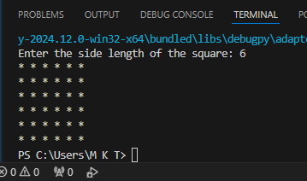

**Task # 02**

Write a Python function that takes a list of numbers as input and returns the sum of only the even numbers.

**Code:**

def sum_of_evens(numbers):

"""

Takes a list of numbers and returns the sum of the even numbers.

Args:

numbers (list): A list of integers or floats.

Returns:

int/float: The sum of the even numbers in the list.

"""

return sum(num for num in numbers if num % 2 == 0)

numbers = [1, 2, 3, 4, 5, 6]

result = sum_of_evens(numbers)

print(f"The sum of even numbers is: {result}")

**Output:**

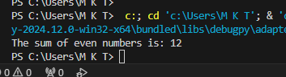

**Task # 03**

Write a Python function that takes a number as input and counts down to zero, printing each number.

**Code:**

def countdown_to_zero(start):

"""

Counts down from the given number to zero, printing each number.

Args:

start (int): The starting number for the countdown.

"""

for i in range(start, -1, -1): # Loop from 'start' to 0 in decrement steps

print(i)

# Example usage

try:

number = int(input("Enter a number to start the countdown: "))

countdown_to_zero(number)

except ValueError:

print("Invalid input! Please enter a valid integer.")

**Output:**

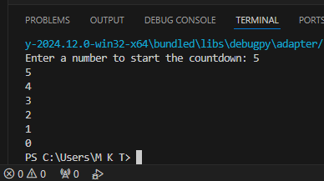s